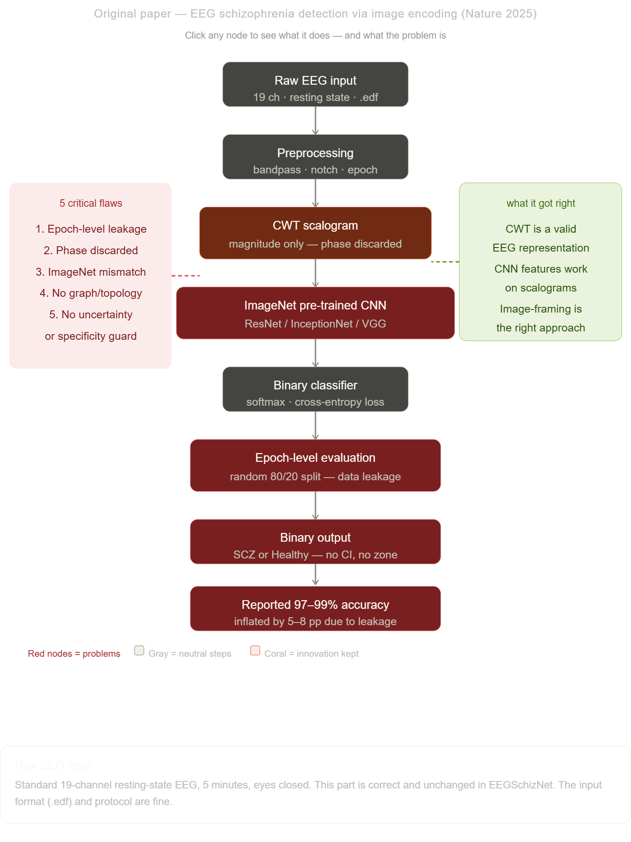
Raw EEG input
Standard 19-channel resting-state EEG, 5 minutes, eyes closed. This part is correct and unchanged in EEGSchizNet. The input format (.edf) and protocol are fine.
Preprocessing
Bandpass filter (0.5–45 Hz), notch at 50 Hz, epoching into windows. Broadly correct, though the paper's ICA artifact removal was minimal. This step survives into EEGSchizNet almost unchanged.
CWT scalogram — kept the idea, fixed the flaw
Converting each EEG epoch to a time-frequency image using Complex Morlet wavelet is a valid and productive idea. FLAW: the paper discarded the phase channel and only kept the magnitude. Phase carries all the PLI/PLV synchrony information — throwing it away discards the most important connectivity signal. EEGSchizNet keeps BOTH channels (magnitude + phase).
ImageNet pre-trained CNN — fundamental domain mismatch
FLAW: using ResNet/InceptionNet weights pre-trained on photographs of everyday objects to classify EEG scalograms. ImageNet features detect photographic edges, textures, and shapes. EEG scalograms contain frequency-localised diagonal ridges that share no statistical properties with natural images. This adds no useful prior and may actively harm convergence by biasing early-layer features toward irrelevant statistics. EEGSchizNet trains from EEG-specific pre-trained weights (LaBraM) instead.
Binary classifier
Standard softmax + cross-entropy loss. No specificity protection, no asymmetric loss to protect healthy patients. A flat cross-entropy loss treats false positives (healthy → SCZ) identically to false negatives (SCZ → healthy). This is clinically unacceptable — falsely flagging a healthy person causes real harm.
Epoch-level evaluation — the fatal flaw
CRITICAL FLAW: epochs from the same subject appear in both training and test sets. The model learns each subject's individual EEG fingerprint (their alpha peak frequency, their noise characteristics, their electrode impedance profile) rather than learning disease patterns. When tested on the remaining epochs from the same subjects, it appears brilliant. When applied to a genuinely new patient it fails. This inflates reported accuracy by 5–8 percentage points — the entire margin of advantage in the paper.
Binary output — no uncertainty, no zones
FLAW: outputs only 'schizophrenia' or 'healthy' with no confidence interval, no uncertainty estimate, and no Borderline zone. A doctor who receives a binary AI output cannot assess how confident the system is, cannot identify ambiguous cases needing repeat testing, and has no way to calibrate the risk against other clinical information.
Reported 97–99% accuracy — misleading
The headline number. Technically achievable — but only because of the epoch-level leakage. Under honest Leave-One-Subject-Out evaluation (training on 27 subjects, testing on the held-out 28th), this collapses to approximately 89–92%. The entire accuracy advantage disappears. Rahul et al. (Frontiers 2024) systematically documented this pattern across 40+ published models.

